**There are 5 projects each worth 20%**

**Project #1**

Complete the following using an array.

**#1 print screen the output with the code below here**

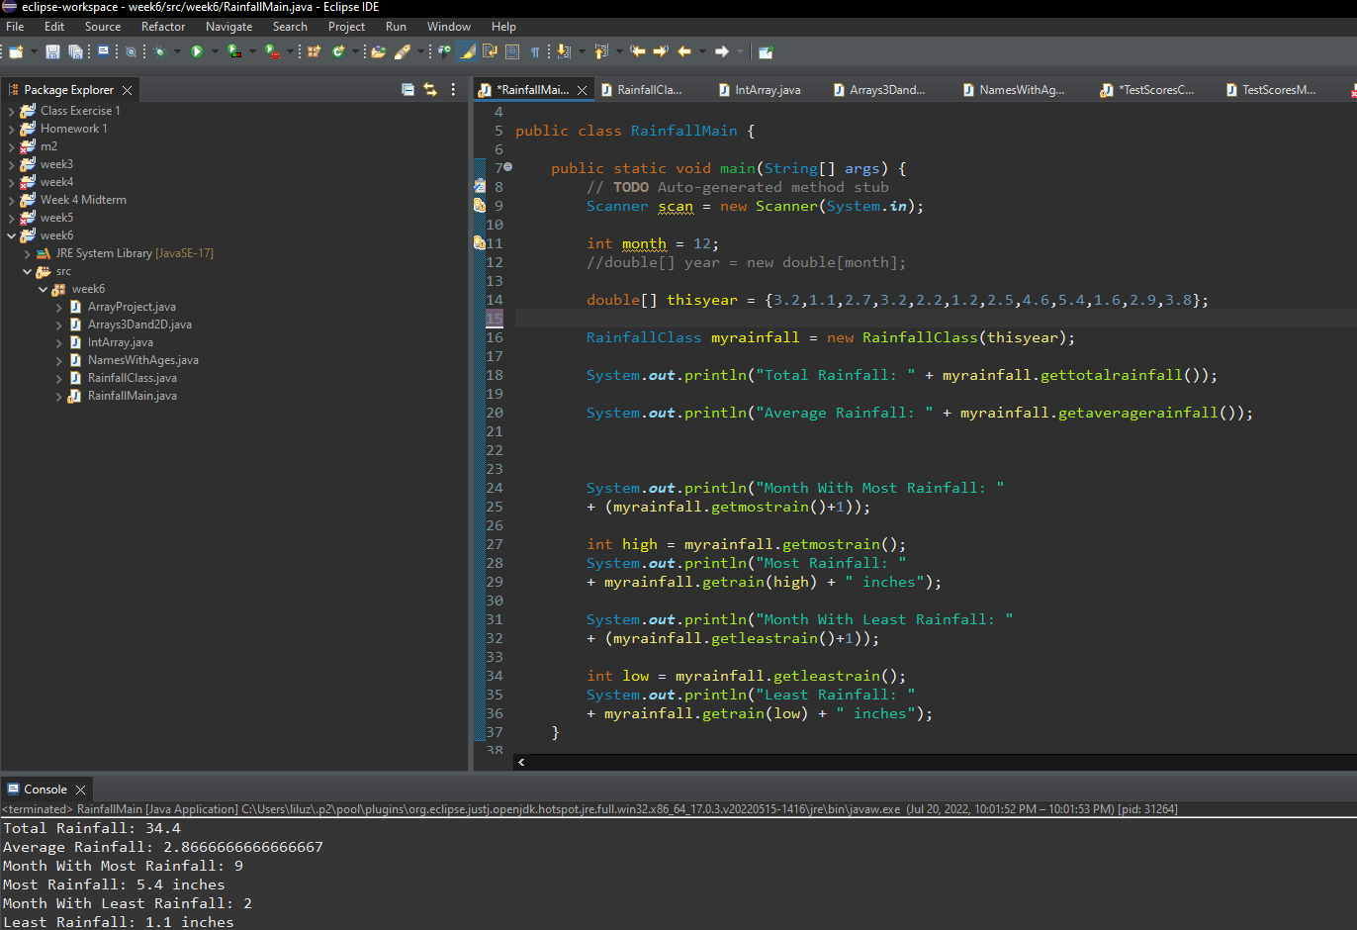

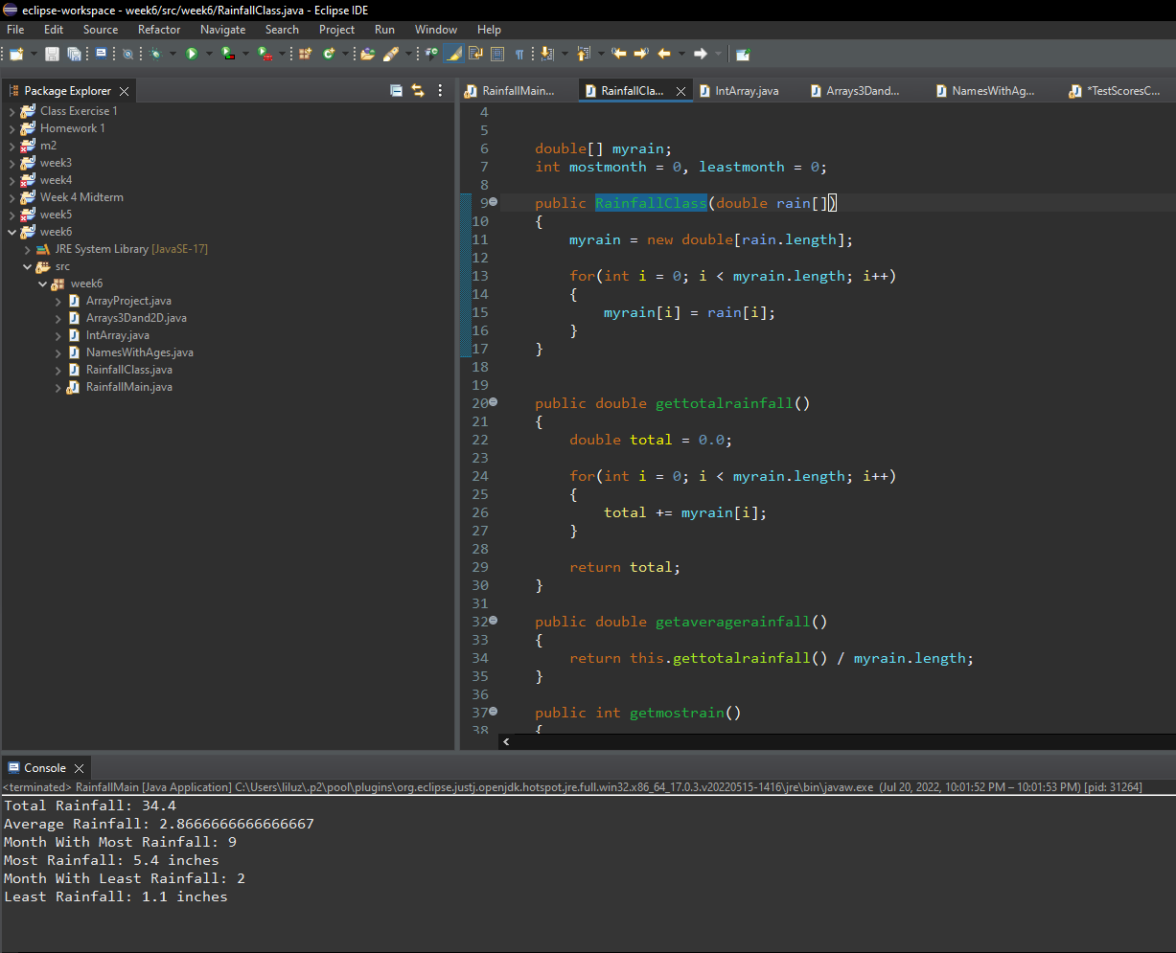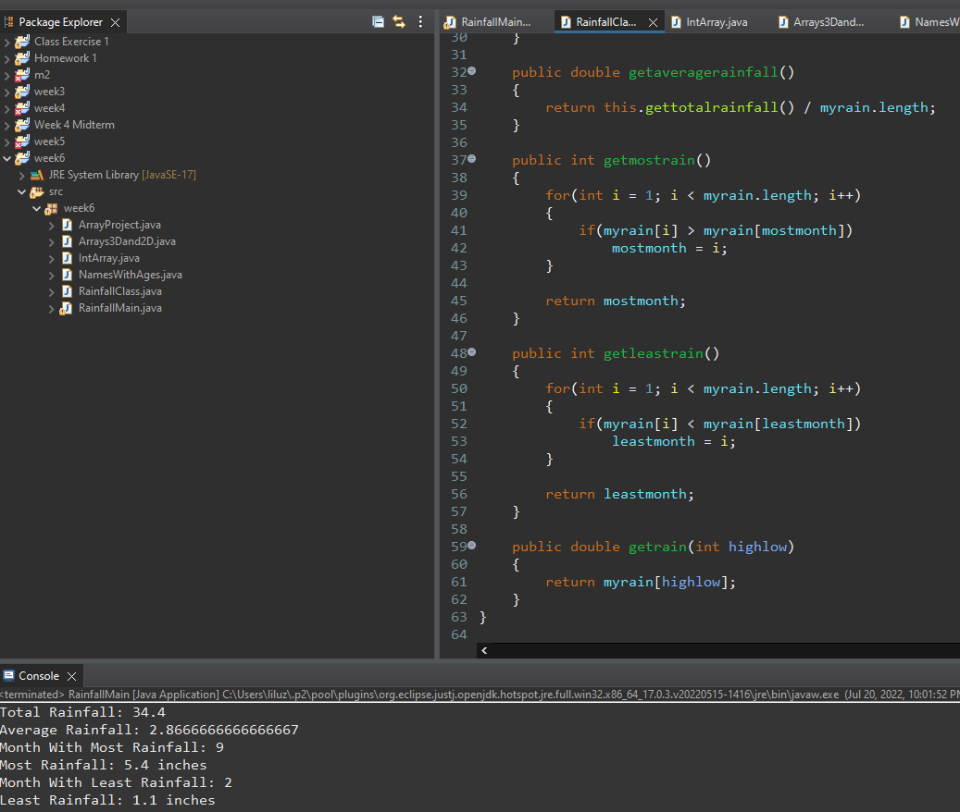

**Project #2**

Complete the following using an array.

**#2 print screen the output with the code below here**

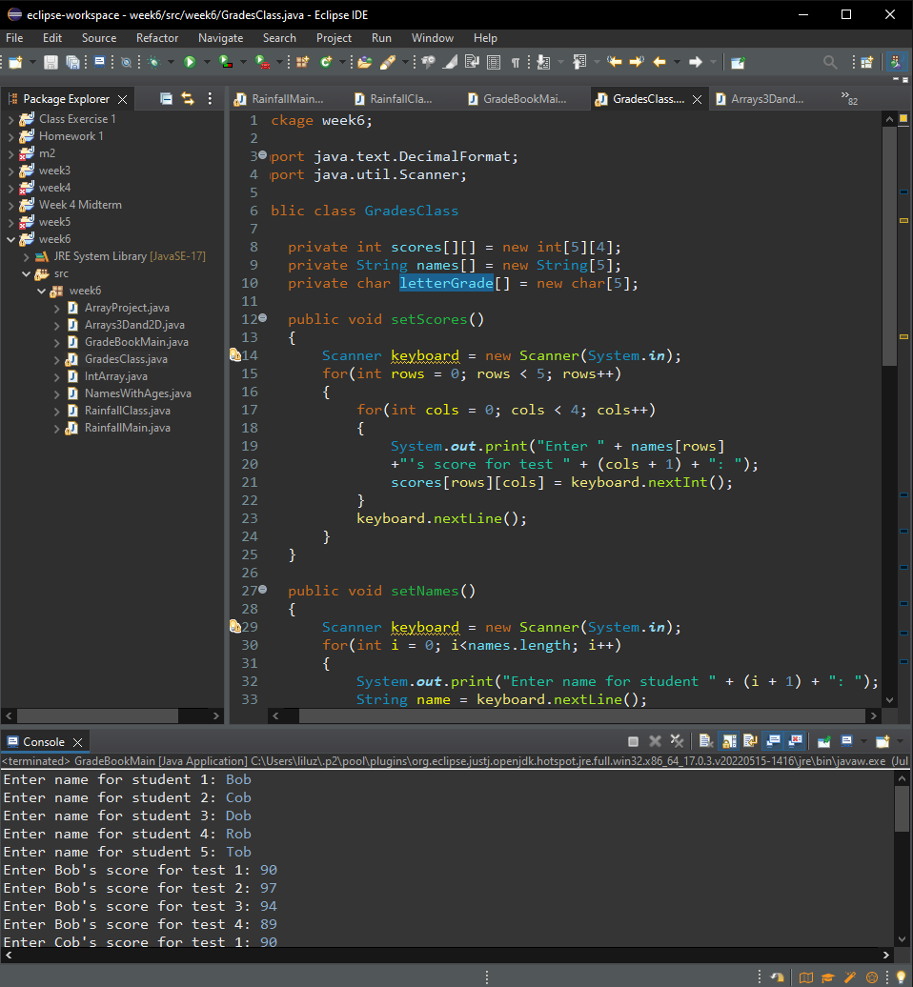

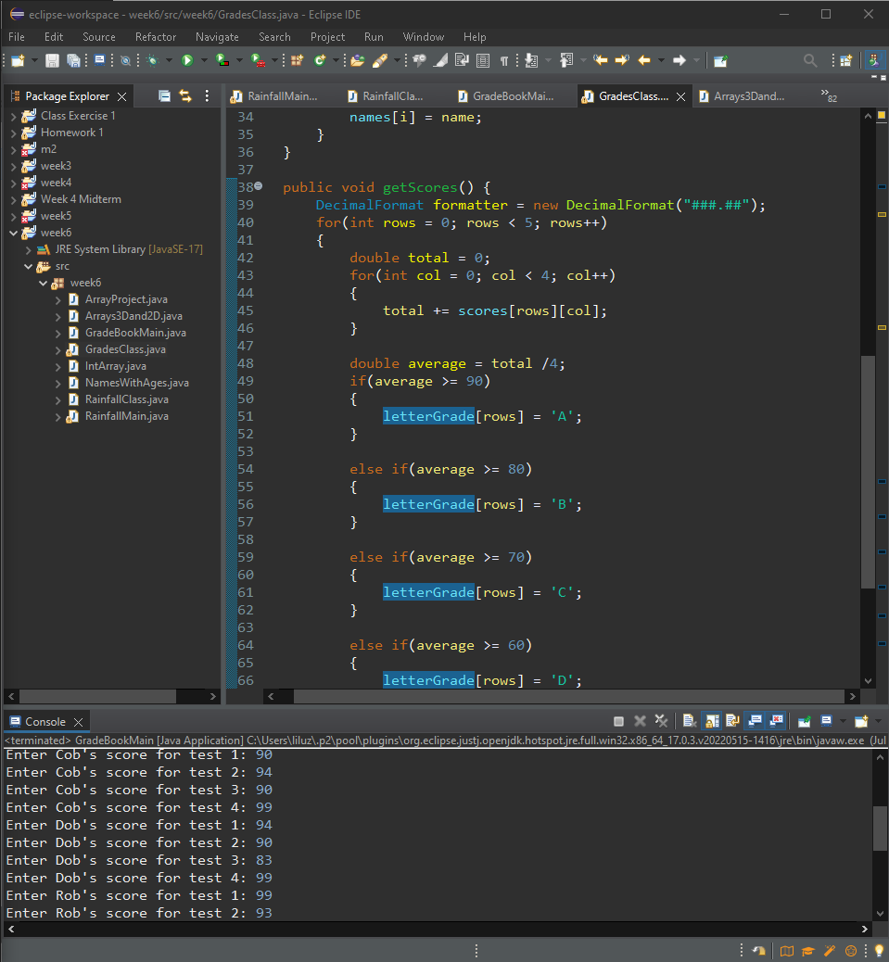

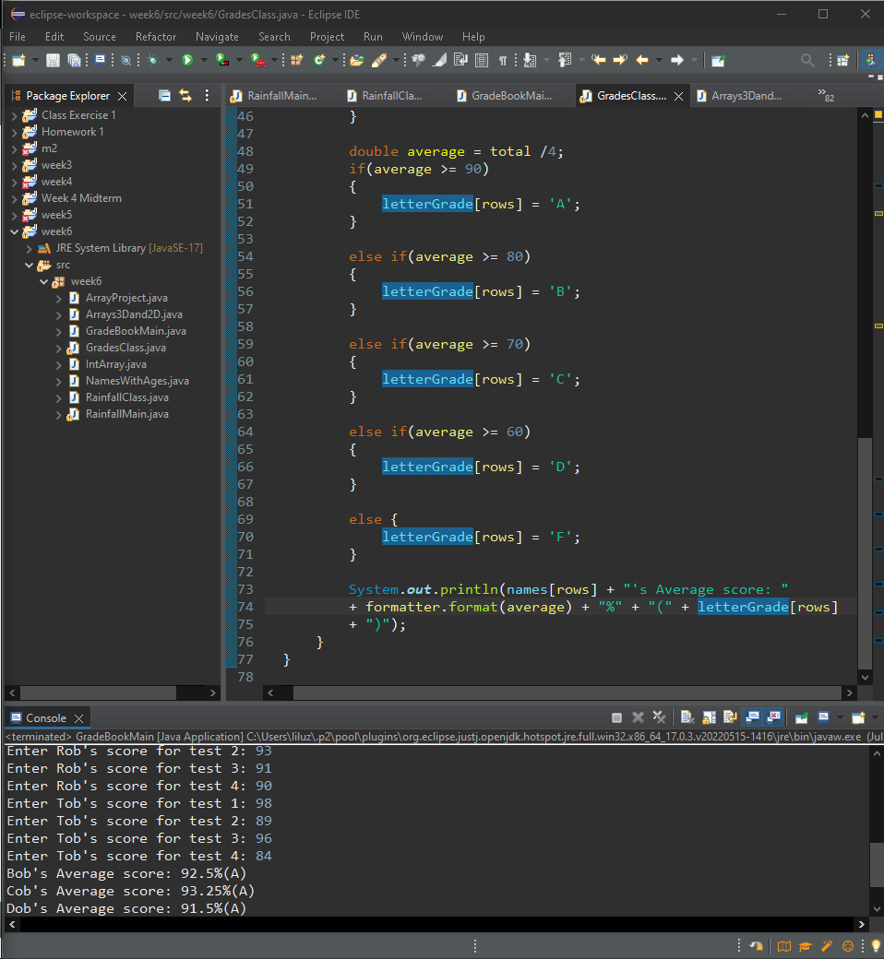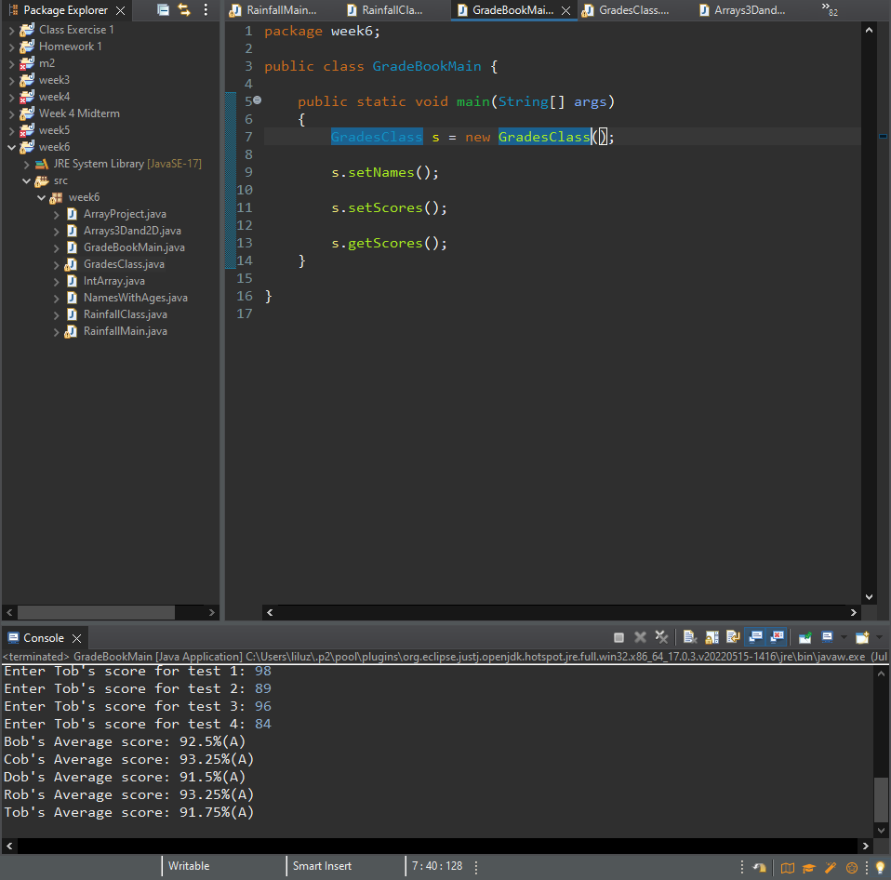

**Project #3**

Create a 1-D List Array for the following numbers 1-10 and sum and average the numbers + lists the numbers 1-10

**#3 print screen the output with the code below here**

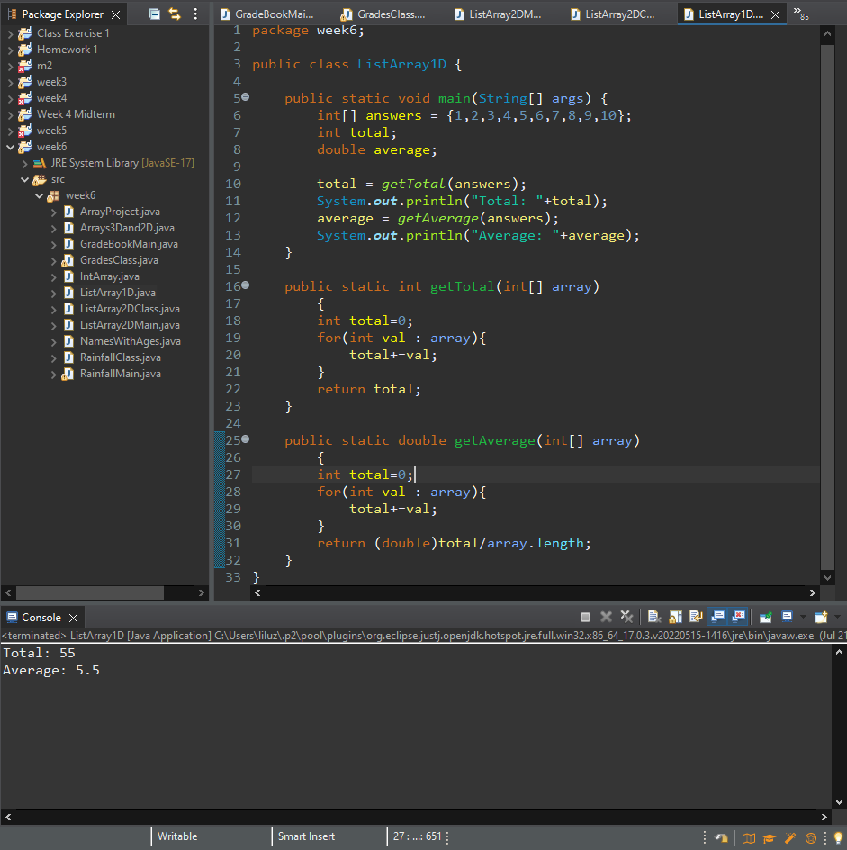

**Project #4**

Create a 2-D List Array for the following numbers 1-10 and sum and average the numbers + lists the numbers 1-10

**#4 print screen the output with the code below here**

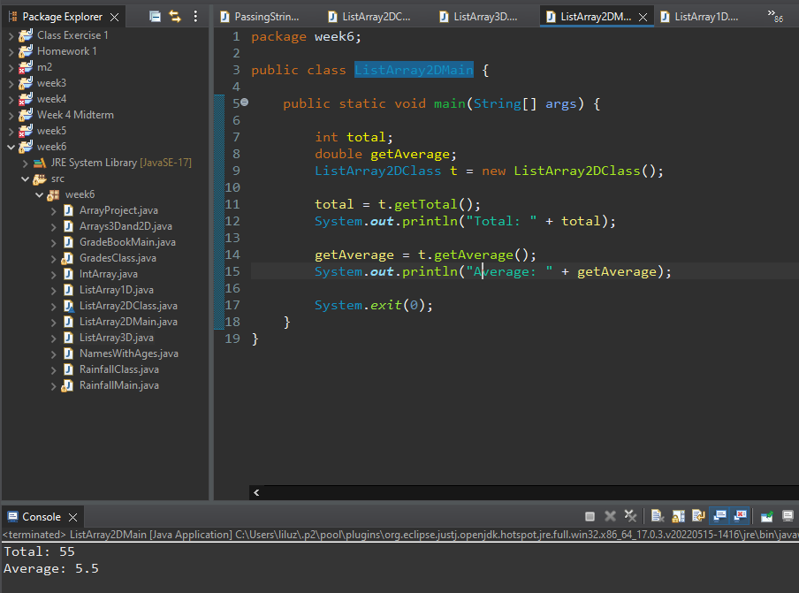

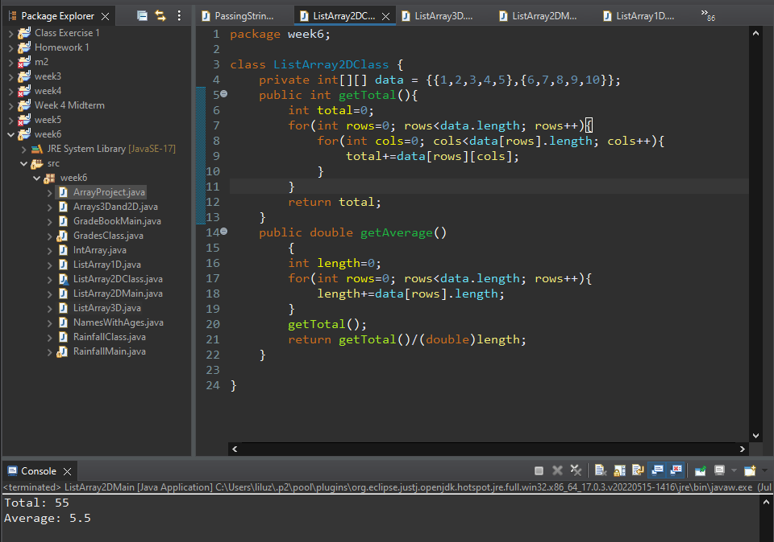

**Project #5**

Create a 3-D List Array for the following numbers 1-12 and sum and average the numbers + lists the numbers 1-12

**#5 print screen the output with the code below here**

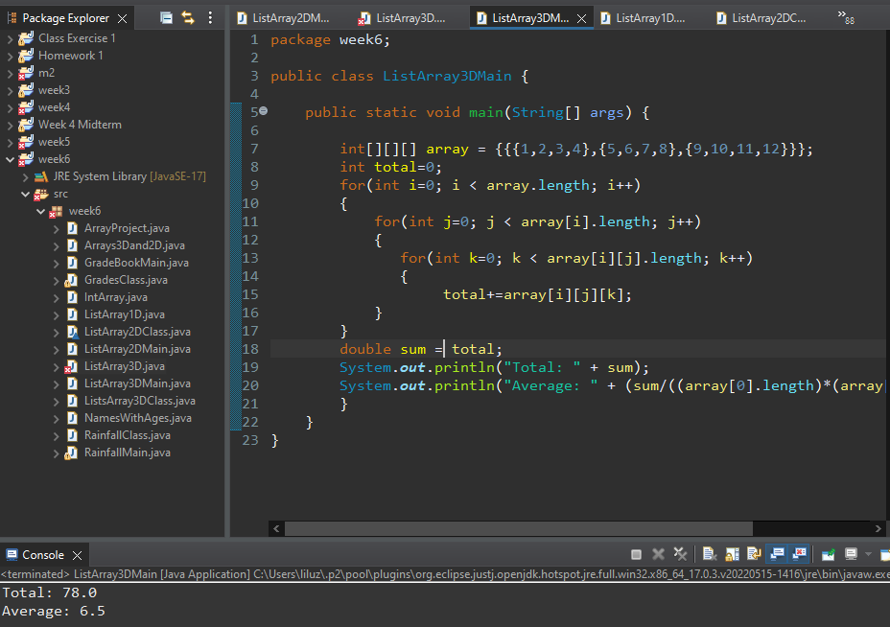

**Submit this document to Module 6 Homework**